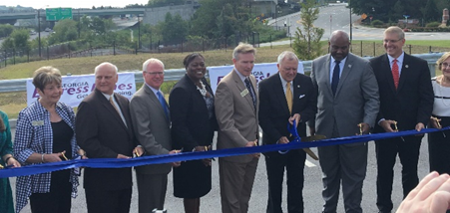
AdWheel Award Submission –
State Road and Tollway Authority
(Peach Pass)
Best Marketing and Communications to Increase Ridership or Sales:
Comprehensive Campaign

November 21, 2018

Target Audience: Commuters living, working, visiting in the Northwest Corridor (NWC) area of Metro Atlanta which includes the counties of Cobb, Cherokee, Bartow, Douglas and Fulton.
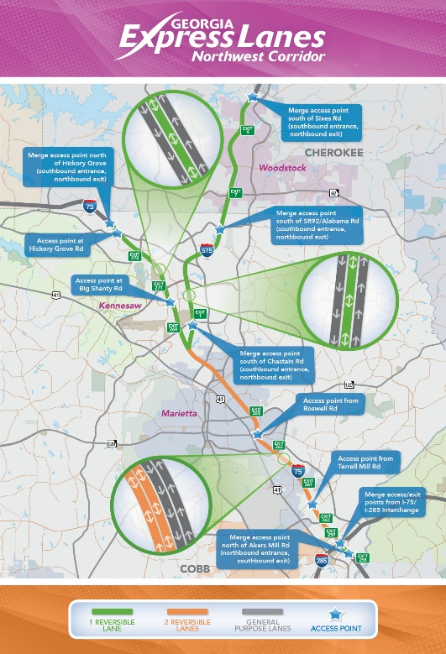
Situation Challenge: Like many municipalities across the United States, Metro Atlanta, Georgia continues to grow both in population size and traffic congestion despite ongoing efforts by government, businesses and organizations to alleviate commute times for both city and suburban residents.
In particular, the Northwest Corridor along Interstate 75 North and Interstate 575 with its surrounding communities have seen unprecedent growth in business and housing development pushing demand for innovative approaches to make commuting easier.
The State Road and Tollway Authority, in partnership with the Georgia Department of Transportation, developed a comprehensive marketing and education outreach campaign across the region promoting Peach Pass usage.
Marketing tactics included Print, Broadcast, Social & Outdoor media including numerous outreach initiatives to support registration and sales.
Strategic Objective: To reduce traffic congestion along the Interstate 75 North and Interstate 575 corridor on its general-purpose lanes and provide more reliable trip times to users.
The organization strategic goals were threefold:
- Drive Peach Pass account registrations among motorists using NWC Express Lanes
- Drive acceptance, adoption & usage of NWC
- Increase the amount of Peach Pass statewide transponders to 75,000 and 25,000 for the NWC region

Results Impact: The NWC Express Lanes were launched on September 10, 2018 and have seen unprecedented commuter usage and support from businesses, local governments and commuters alike.
SRTA achieved its strategic goal of 62,000 Peach Pass transponders statewide by August 2018 and as of November 20, 2018, current numbers were at 123,064 for Peach Pass transponders/tags and 78,370 in accounts.
SRTA also met and exceeded its original goal of 25,000 for the number of transponders in the Northwest Corridor region, starting July 1, 2017. As of October 2018, SRTA has generated 69, 434 transponders and 42,334 account so far.
As of November 2018, motorists took 471,550 trips on the Northwest Corridor during its first month of operation. Commuters are taking more than 20,000 trips on an average weekday.
Why Submit: The NWC project was recently named the No. 1 transportation project on Roads & Bridges’ 2018 Top 10 Roads list.
Additionally, the SRTA marketing and outreach campaign has helped to drive and exceed Peach Pass account registrations goals, increase usage & acceptance of the express lanes along the Interstate 75 North corridor and provided commuters with improved options to commute to and from work.
As the largest transportation project in Georgia history, we believe our successful Marketing and Outreach campaign to promote and educate commuters along the 30-mile-long NWC Express Lanes is worthy of recognition by APTA and its members.

NWC MEDIA CAMPAIGN
Communications Strategies
The Northwest Corridor Express Lane Media Campaign was focused on leveraging multi-channel communications to create high visibility and education about the benefits of using a Peach Pass and the ease in obtaining and maintaining one. Additionally, our efforts were to accomplish the following:

- Educate motorists about the NWC Express Lanes, from how the reversible lanes work to the safety features.
- Create relevance with commuters by framing the story of price managed lanes in a way that engenders support for the NWC Express Lanes.
- Celebrate positive stories from I-75 South Metro Express Lanes and highlight our community involvement as well in the surrounding areas.
- Use and tout extensive data in new and different ways to quantify the benefits of Peach Pass, Georgia Express Lanes.
- Demonstrate transparency and build trust by communicating early and often and soliciting feedback where necessary
- Work in coordination with the Governor’s Office and GDOT to provide consistent, seamless communications to public and other stakeholders.
NWC MEDIA FLOCART
Below is a breakout of the NWC media schedule flowchart which highlights several marketing tactics used to drive awareness for Peach Pass and the Express Lanes including Sports Marketing, Digital Outdoor, Cable TV, Radio, Mobile Apps, Social Media and Community Outreach.

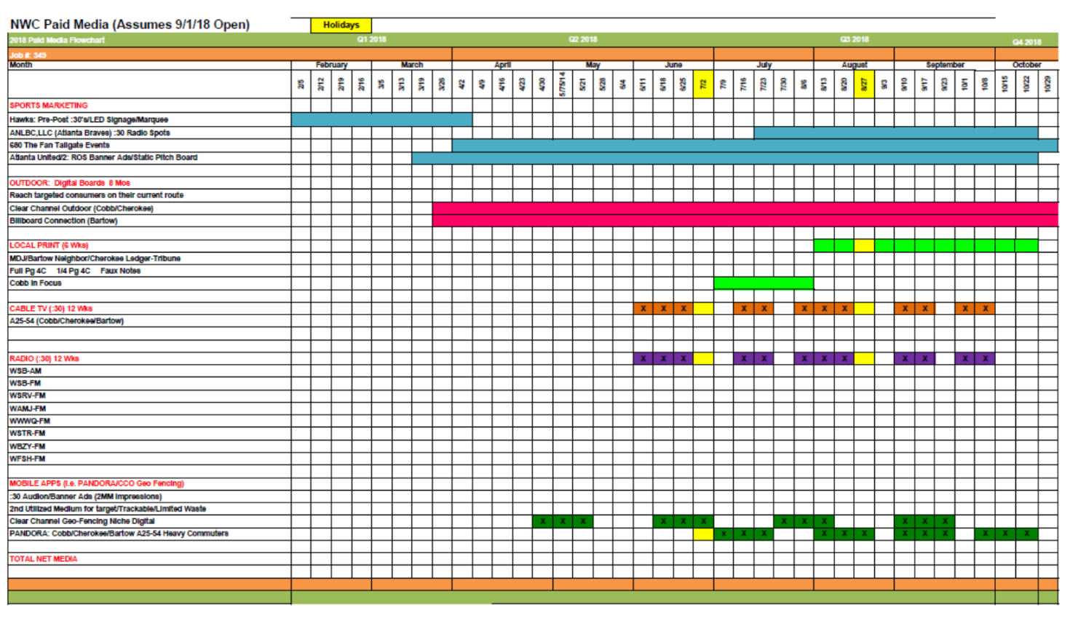

COMMUNITY OUTREACH
SRTA, along with agencies and Marketing and Communications teams, spearheaded an aggressive community outreach schedule meeting and embracing the public directly with targeted messaging about the Peach Pass product and the NWC Express lanes.
Among the initiatives included:
Grand Opening of Dept of Driver Services Location in Kennesaw, GA – July 13, 2018
DDS site included retail area to sell Peach Pass products to residents in the NWC area and promote education and awareness about the Express Lanes. https://www.srta.ga.gov/peach-pass-opens-new-retail-center-in-kennesaw/

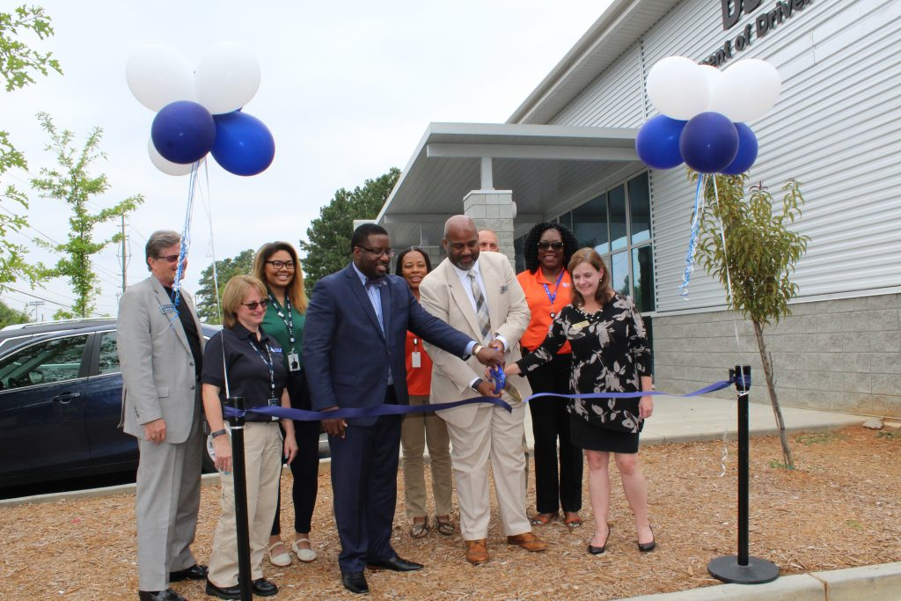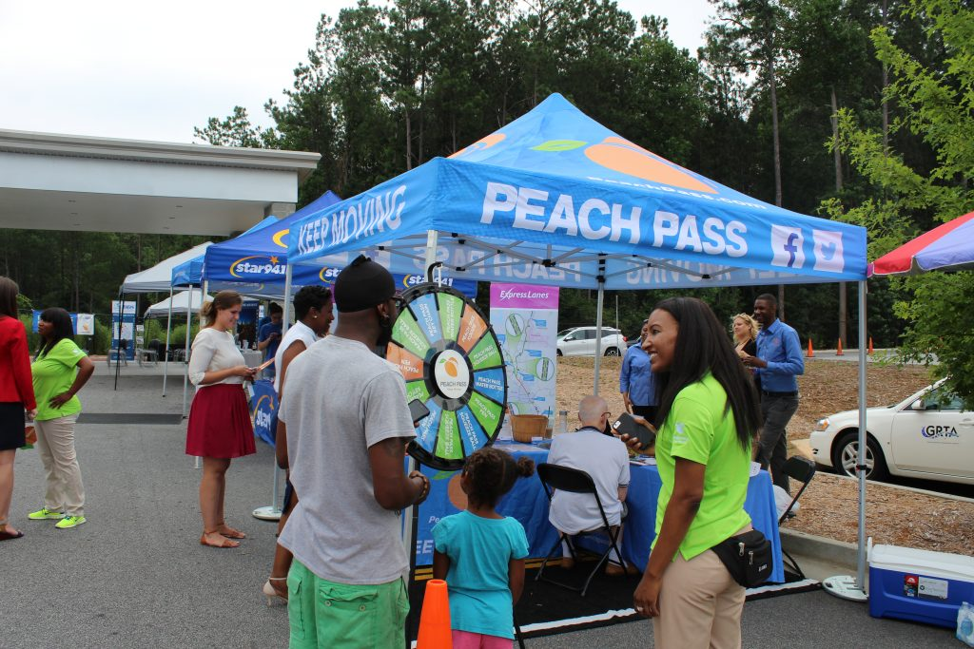

NWC Grand Opening – September 10, 2018
The NWC Express Lane grand opening was held at Sun Trust Park in Marietta, Georgia on September 10, 2018. Governor Nathan Deal of Georgia, SRTA Executive Director Chris Tomlinson and various regional and local dignitaries were in attendance. The $870 million dollar, 30-mile-long Express Lane was the largest transportation project in Georgia history.

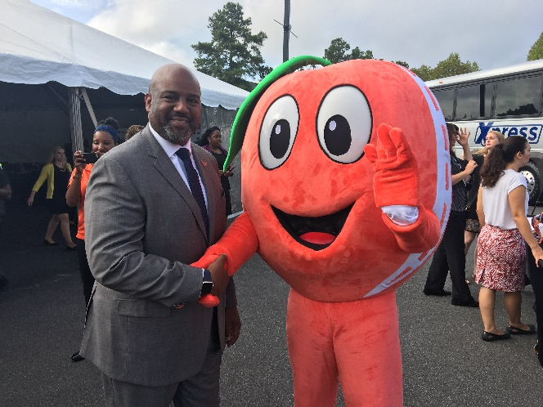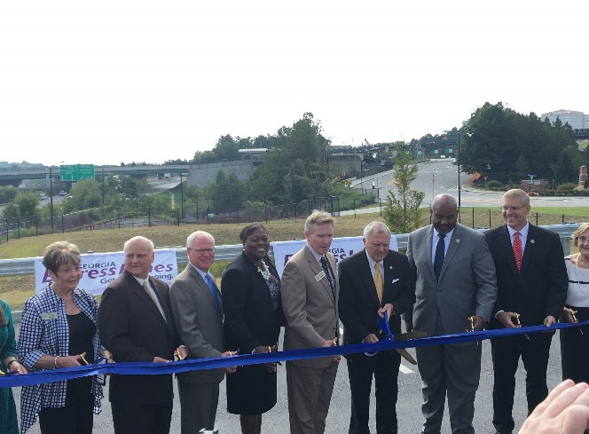

Local Community Events
SRTA, with its community outreach team, traveled throughout Metro Atlanta promoting the benefits of Peach Pass and educating the public at large about the NWC Express lanes. The outreach teams visited targeted festivals, local events, concerts, corporations, schools and businesses organizations distributing education materials and generating Peach Pass sales by selling accounts on-site.

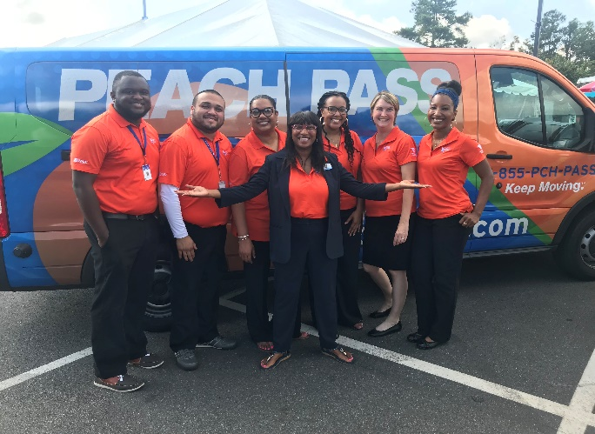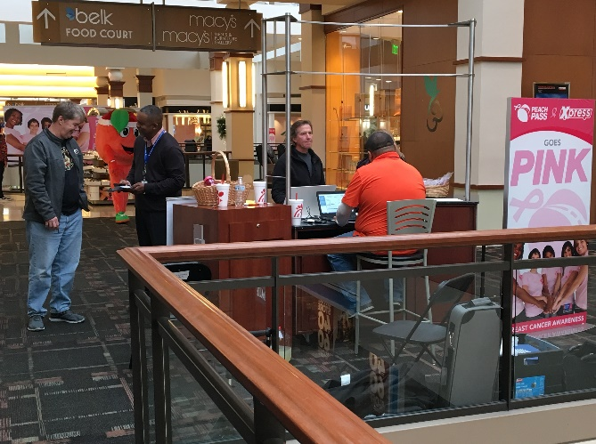
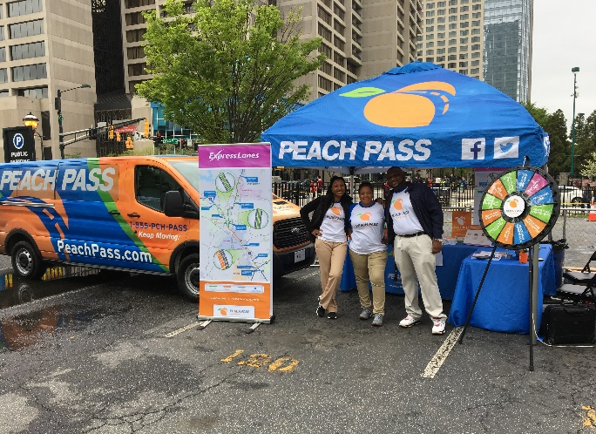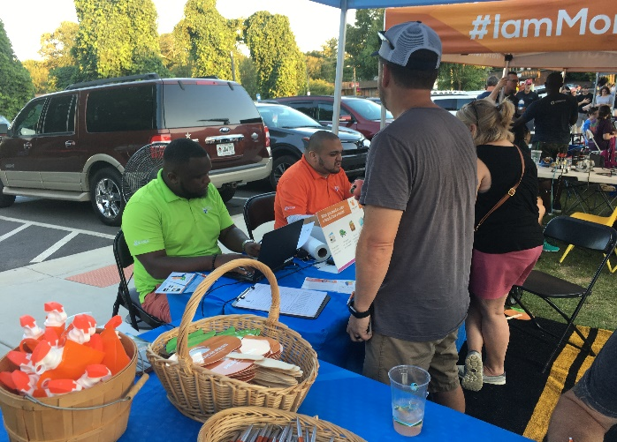
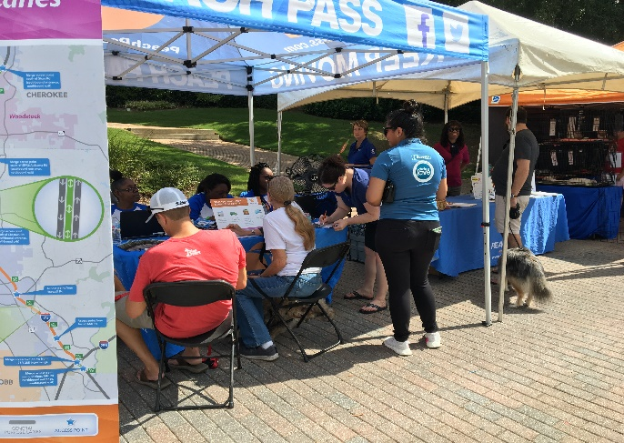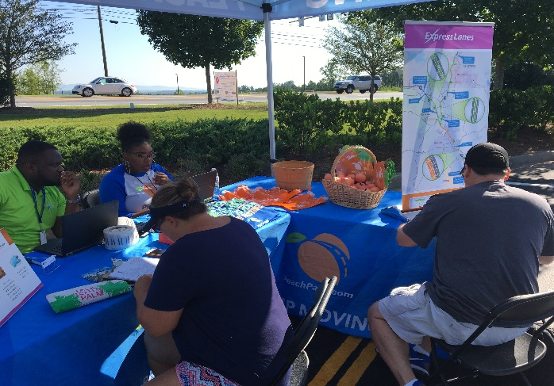

SUPPORTING ARTICLES
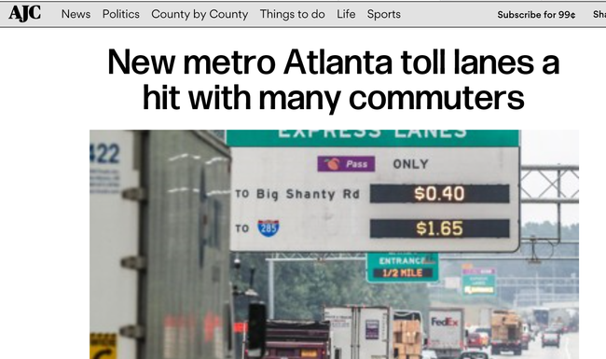
New metro Atlanta toll lanes a hit with many commuters
https://www.ajc.com/news/local-govt--politics/new-metro-atlanta-toll-lanes-hit-with-many-commuters/cXgmGHSnQkZHnOhLOBfwIL/

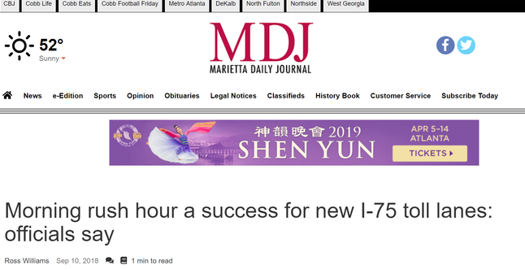
Morning rush hour a success for new I-75 toll lanes: officials say
https://www.mdjonline.com/news/morning-rush-hour-a-success-for-new-i--toll/article_1c3ef7b0-b544-11e8-806f-ef2a9192acc0.html

